SAFETY DATA SHEET
according to (EU) Regulation 2015/830
Page 1/6
Revision: 1
Revision date: 19/12/2023

YELLOW NON-AMMONIATED CLOCK CLEANER CONC

SECTION 1: Identification of the substance/mixture and of the company/undertaking
1.1. Product identifier
Product name YELLOW NON-AMMONIATED CLOCK CLEANER CONC

1.2. Relevant identified uses of the substance or mixture and uses advised against
Product Use [SU21] Consumer uses: Private households; [SU22] Professional uses: Public domain; [PC35] Washing and cleaning products (including solvent based products) [ERC8a] Wide dispersive outdoor use of processing aids in open systems;

Description NON-AMMONIATED CLOCK CLEANER CONC

1.3. Details of the supplier of the safety data sheet
Company H&P Storey
Address 19 Jericho Road (off Staple Road)
Balderton
Newark
Nottinghamshire
NG24 3GT

Web www.hpstorey.co.uk
Telephone 01636 676 381
Fax
Email charlotte@hpstorey.co.uk
Email address of the competent person

` charlotte@hpstorey.co.uk

1.4. Emergency telephone number
01636 676 381 9.00 am - 5.00 pm Mon – Fri

SECTION 2: Hazards identification
2.1. Classification of the substance or mixture

2.2. Label elements
Label elements under CLP:
Hazard statements: Flam. Liq. 3: H226 - Flammable liquid and vapour.
Skin Corr 1B H314 - Causes severe skin burns and eye damage
STOT SE 3: H336 - May cause drowsiness or dizziness.
STOT SE 3H335, - May cause respiratory irritation

Signal words: Warning
Hazard pictograms: 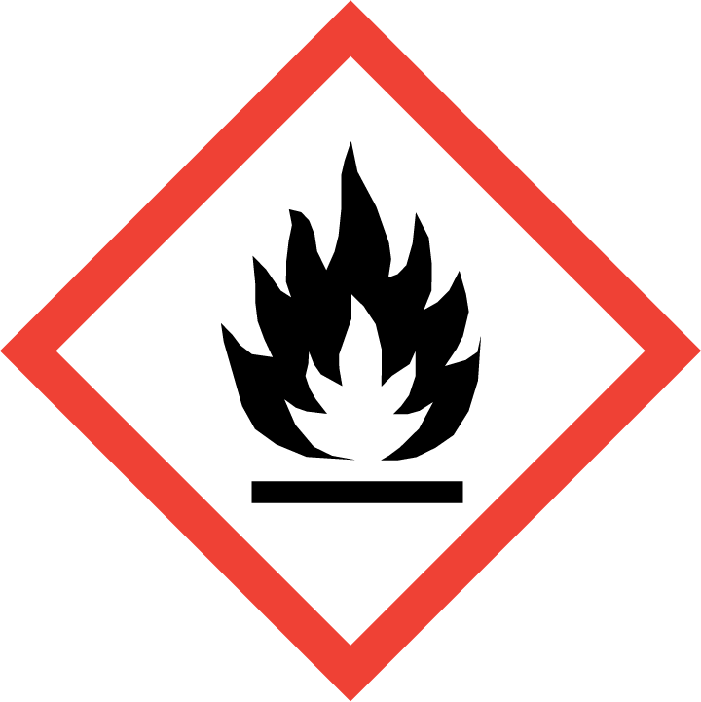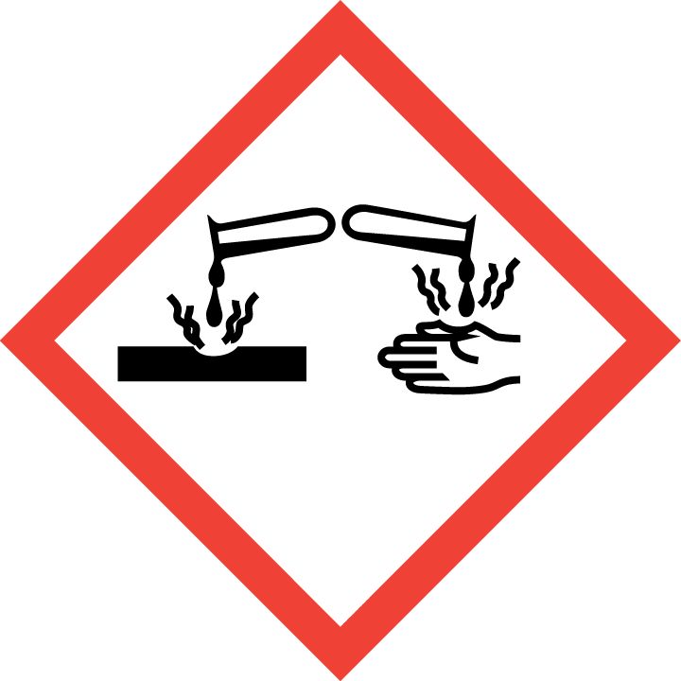

Precautionary statements: P102: Keep out of reach of children.
P210 - Keep away from heat, hot surfaces, sparks, open flames and other ignition sources. No
smoking.
P260: Do not breathe dust/fume/gas/mist/vapours/spray
P280: Wear protective gloves/protective clothing/eye protection/face protection.
P303+361+353: IF ON SKIN (or hair): Remove immediately all contaminated clothing.
Rinse skin with water/shower.
P304+P340 - IF INHALED: Remove person to fresh air and keep comfortable for breathing.
P305+351+338: IF IN EYES: Rinse cautiously with water for several minutes. Remove
contact lenses, if present and easy to do. Continue rinsing.
P363: Wash contaminated clothing before reuse.
P501: Dispose of contents to hazardous waste.

YELLOW NON-AMMONIATED CLOCK CLEANER CONC
Page 2/6
Revision: 1
Revision date: 19/12/2023

2.3. Other hazards
PBT: This product is not identified as a PBT substance.

SECTION 3: Composition/information on ingredients
3.2. Mixtures
EC 1272/2008
Chemical Name CAS No. EC No. REACH Registration Conc. Classification
Number (%w/w)
Propan-2-ol 67-63-0 200-661-7 20 – 40 Flam. Liq. 2: H225;
Eye Irrit. 2: H319; STOT SE 3: H336;

Tetrasodium 64-02-8 200-573-9 01-2119486762-27 0.5 - 1% Acute Tox. 4: H302;
ethylenediaminetetraacetate Eye Irrit. 2: H319;

Acute Tox. 4 - H302 Acute Tox. 4 - H312 Acute Tox. 4 - H332 Skin Corr. 1B - H314 Eye Dam. 1 - H318 STOT SE 3 - H335
SPECIFIC CONCENTRATION LIMITS:-
STOT SE 3; H335: C ≥ 5 %
2 Aminoethanol 205-483-3 141-43-5 01-2119486455-28-xxxx 5 20% -

ALSO CONTAINS, SOAP AT LEVELS BELOW CLASSIFICATION

SECTION 4: First aid measures
4.1. Description of first aid measures
Inhalation Move the exposed person to fresh air.
Eye contact Rinse immediately with plenty of water for 15 minutes holding the eyelids open.
Skin contact Wash off immediately with plenty of soap and water. Remove contaminated clothing.
Ingestion DO NOT INDUCE VOMITING.

4.2. Most important symptoms and effects, both acute and delayed
Inhalation Inhalation may cause coughing, tightness of the chest and irritation of the respiratory system.
Eye contact Risk of serious damage to eyes
Skin contact Causes severe irritation/ skin burns.
Ingestion Ingestion may cause nausea and vomiting.

4.3. Indication of any immediate medical attention and special treatment needed
Inhalation If you feel unwell, seek medical advice (show the label where possible).
Eye contact Seek medical attention.
Skin contact Seek medical attention if irritation or symptoms persist.
Ingestion If you feel unwell, seek medical advice (show the label where possible).

SECTION 5: Firefighting measures
5.1. Extinguishing media
Use extinguishing media appropriate to the surrounding fire conditions.

5.2. Special hazards arising from the substance or mixture
Burning produces irritating, toxic and obnoxious fumes.

5.3. Advice for firefighters
Wear self-contained breathing apparatus and protective clothing.
SECTION 6: Accidental release measures
6.1. Personal precautions, protective equipment and emergency procedures
Ensure adequate ventilation of the working area. Avoid contact with skin and eyes.

6.2. Environmental precautions
Do not allow product to enter drains. Prevent further spillage if safe.

6.3. Methods and material for containment and cleaning up
Transfer to suitable, labelled containers for disposal. Clean spillage area thoroughly with plenty of water.

6.4. Reference to other sections
See section 8. EXPOSURE CONTROLS / PERSONAL PROTECTION for further information.
See section 13. DISPOSAL CONSIDERATIONS for further information.

YELLOW NON-AMMONIATED CLOCK CLEANER CONC
Page 3/6
Revision: 1
Revision date: 19/12/2023
SECTION 7: Handling and storage
7.1. Precautions for safe handling
Ensure adequate ventilation of the working area. Avoid contact with eyes and skin.
Adopt best Manual Handling considerations when handling, carrying and dispensing.

7.2. Conditions for safe storage, including any incompatibilities
Keep containers tightly closed. Keep in a cool, dry, well-ventilated area.
Store in correctly labelled containers.

7.3. Specific end use(s)
See section 1.2. Relevant identified uses of the substance or mixture and uses advised against for further information.

SECTION 8: Exposure controls/personal protection

8. EXPOSURE CONTROLS/PERSONAL PROTECTION
8.1 Control parameters
Component | CAS Number | Value | Control Parameters | Update | Basis
ISOPROPANOL | 67-63-0 | TWA | 400 ppm  999 mg/m3 | 2007 | EH40 WEL
 |  | STEL | 500 ppm  1,250 mg/m3 | 2007 | EH40 WEL

DNEL
propan-2-ol; isopropyl End Use: Workers alcohol; isopropanol Exposure routes: Skin contact
Potential health effects: Chronic effects
Exposure time: 1 d
Value: 888 mg/kg

End Use: Workers
Exposure routes: Inhalation
Potential health effects: Chronic effects
Value: 500 mg/m3

End Use: Consumers
Exposure routes: Skin contact
Potential health effects: Chronic effects
Exposure time: 1 d
Value: 319 mg/kg

End Use: Consumers
Exposure routes: Inhalation
Potential health effects: Chronic effects
Value: 89 mg/m3

End Use: Consumers
Exposure routes: Ingestion
Potential health effects: Chronic effects
Exposure time: 1 d
Value: 26 mg/kg
PNEC
propan-2-ol; isopropyl Fresh water alcohol; isopropanol Value: 140.9 mg/l

Marine water
Value: 140.9 mg/l

Fresh water sediment
Value: 552 mg/kg

Marine sediment
Value: 552 mg/kg

Soil
Value: 28 mg/kg

YELLOW NON-AMMONIATED CLOCK CLEANER CONC
Page 4/6
Revision: 1
Revision date: 19/12/2023
COMPONENT:-
2-AMINOETHANOL
Long-term exposure limit (8-hour TWA): WEL 1 ppm 2.5 mg/m³
Short-term exposure limit (15-minute): WEL 3 ppm 7.6 mg/m³ Sk
WEL = Workplace Exposure Limit
Sk = Can be absorbed through the skin.
Derived No Effect Level (DNEL)
Workers
Dermal; Long term systemic effects: 1 mg/kg
Workers - Inhalation; Long term local effects: 3.3 mg/m³
Consumer - Dermal; Long term systemic effects: 0.24 mg/l
Consumer - Oral; Long term systemic effects: 3.75 mg/kg
Consumer - Inhalation; Long term local effects: 2 mg/m³
Predicted No Effect Concentration (PNEC)
Fresh water; 0.085 mg/l
Marine water; 0.0085 mg/l
Intermittent release; 0.025 mg/l
STP; 100 mg/l
Fresh water, Sediment; 0.425 mg/kg
Marine water, Sediment; 0.0425 mg/kg
Soil; 0.035 mg/kg

COMPONENT:-
Tetrasodium
ethylenediaminetetraacetate

DNELs tetrasodium ethylenediaminetetraacetate
Oral | DNEL Long-term - Systemic (consumer) | 25 mg/kg bw/day (/)
Inhalative | DNEL Acute - Local (consumer) | 1.5 mg/m³ (/)
 | DNEL Acute - Systemic (consumer) | 1.5 mg/m³ (/)
 | DNEL Acute - Systemic (worker) | 2.5 mg/m³ (/)
 | DNEL Acute - local (worker) | 2.5 mg/m³ (/)

PNECs tetrasodium ethylenediaminetetraacetate
PNEC Fresh water | 2.2 mg/l (/)

8.2. Exposure controls
8.2.1. Appropriate engineering controls
Ensure adequate ventilation of the working area.

8.2.2. Individual protection measures Wear protective clothing.

Eye / face protection Approved safety goggles.
Skin protection – Hand protection Wear suitable gloves.
Skin protection - Other Wear suitable protective clothing.
Respiratory protection Wear suitable respiratory equipment when necessary.
Occupational exposure controls Keep away from food, drink and animal feedingstuffs.

SECTION 9: Physical and chemical properties
9.1. Information on basic physical and chemical properties
Appearance Liquid
Colour: Blue
Odour: Characteristic
Odour threshold: Not determined.
pH-value at 20 °C: 7.0 Nominal
Melting point: Not determined.
Boiling point: Not determined.
Flash point: 29ºC.Nominal
Flammability (solid, gaseous): Not applicable.
YELLOW NON-AMMONIATED CLOCK CLEANER CONC
Page 5/6
Revision: 1
Revision date: 19/12/2023

Auto-ignition temperature: Not determined.
Decomposition temperature: Not determined.
Self-igniting: Not determined.
Danger of explosion: Product does not present an explosion hazard.
Explosion limits: Not determined.
Vapour pressure: Not determined.
Density at 20 °C: 0.910 Nominal
Relative density Not determined.
Particle characteristics Not applicable
Vapour density Not determined.
Evaporation rate Not determined.
Solubility in / Miscibility with water: Fully miscible.
oxidizing properties Not determined.
Partition coefficient (n-octanol/water): Not determined.
Viscosity:
Dynamic at 20 °C: Not determined.
Kinematic: Not determined.

9.2. Other information
Conductivity No data available
Surface tension No data available
Gas group No data available

SECTION 10: Stability and reactivity
10.1. Reactivity Stable under normal conditions.

10.2. Chemical stability Stable under normal conditions.

10.3. Possibility of hazardous reactions
No data is available on this product.

10.4. Conditions to avoid
No data is available on this product.

10.5. Incompatible materials
No data is available on this product.

10.6. Hazardous decomposition products
No data is available on this product.

SECTION 11: Toxicological information

11.1. Information on toxicological effects
Skin corrosion/irritation May cause irritation to skin.
Serious eye damage/irritation May cause irritation to eyes.

11.1.4. Toxicological Information
Acute toxicity: Not determined.

SECTION 12: Ecological information
12.1. Toxicity Not determined.

12.2. Persistence and degradability
No data is available on this product.

12.3. Bioaccumulative potential
No data is available on this product.

Partition coefficient No data available

12.4. Mobility in soil No data is available on this product.

12.5. Results of PBT and vPvB assessment
No data is available on this product.

12.6. Other adverse effects
No data is available on this product.
YELLOW NON-AMMONIATED CLOCK CLEANER CONC
Page 6/6
Revision: 1
Revision date: 19/12/2023
SECTION 13: Disposal considerations
13.1. Waste treatment methods
Dispose of in compliance with all local and national regulations.

SECTION 14: Transport information
14.1. UN number
UN number: UN 1993

14.2. UN proper shipping name
Shipping name: FLAMMABLE LIQUID, N.O.S. (contains Propan-2-ol)

14.3. Transport hazard class(es)
Transport class: 3 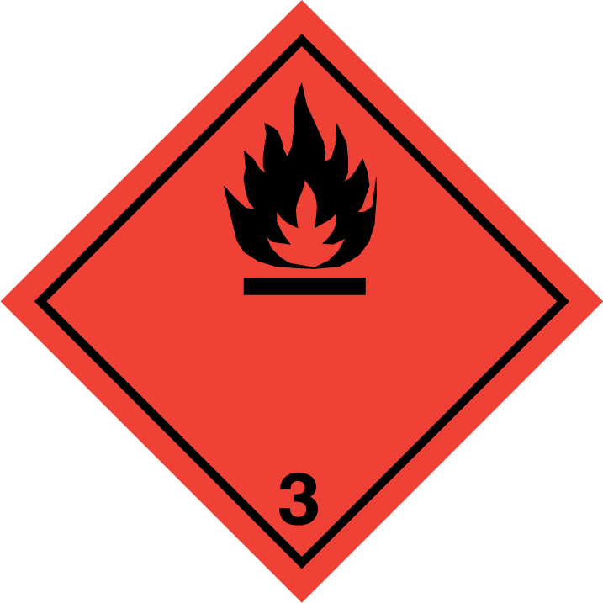
14.4. Packing group
Packing group: III

14.5. Environmental hazards
Environmentally hazardous: No
Marine pollutant: No

14.6. Special precautions for user
Tunnel code: D/E
Transport category: 3

14.7. Transport in bulk according to Annex II of MARPOL 73/78 and the IBC Code
This product is not intended to be transported in bulk.

SECTION 15: Regulatory information

15.1. Safety, health and environmental regulations/legislation specific for the substance or mixture
according to 1907/2006/EC, with its amendment Regulation (EU) 2015/830
REGULATION (EC) No 1907/2006 OF THE EUROPEAN PARLIAMENT AND OF THE COUNCIL of 18 December 2006 concerning the Registration, Evaluation, Authorisation and Restriction of Chemicals (REACH), establishing a European Chemicals Agency, amending Directive 1999/45/EC and repealing Council Regulation (EEC) No 793/93 and Commission Regulation (EC) No 1488/94 as well as Council Directive 76/769/EEC and Commission Directives 91/155/EEC, 93/67/EEC, 93/105/EC and 2000/21/EC
15.2. Chemical safety assessment
No data is available on this product.

SECTION 16: Other information
Other information
Revision 1
This document differs from the previous version in the following areas:
2.2. Label elements Hazard statements:
3.2. Mixtures
4.2. Most important symptoms and effects, both acute and delayed
8.1 Control parameters

Text of Hazard Statements in Section 3
Flam. Liq. 2: H225 Highly flammable liquid and vapour.
Acute Tox. 4: H302 Harmful if swallowed
Acute Tox 4: H312 Harmful in contact with skin
Skin Corr. 1A: H314 Causes severe skin burns and eye damage
Eye Dam. 1: H318 Causes serious eye damage.
Eye Irrit. 2: H319 Causes serious eye irritation.
Acute Tox. 4 H332 Harmful if inhaled
STOT SE 3: H335 May cause respiratory irritation
STOT SE 3: H336 May cause drowsiness or dizziness.

Further information
The information supplied in this Safety Data Sheet is designed only as guidance for the safe use, storage and handling of the product. This information is correct to the best of our knowledge and belief at the date of publication however no guarantee is made to its accuracy. This information relates only to the specific material designated and may not be valid for such material used in combination with any other materials or in any other process.

